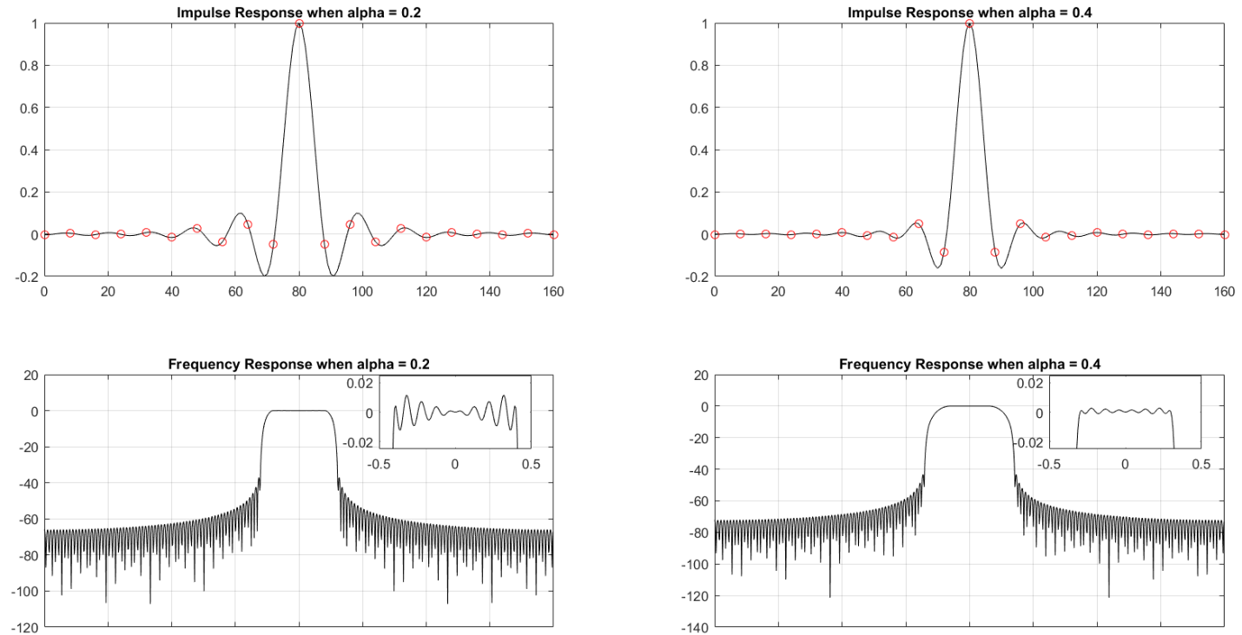Problem 1)

% Filter 1: roll off factor 0.2

h1 = rcosine(1, 8, 'sqrt', 0.2, 10);

h1 = h1/max(h1);

% Filter 2: roll off factor 0.4

h2 = rcosine(1, 8, 'sqrt', 0.4, 10);

h2 = h2/max(h2);

subplot(2,2,1);

plot(0:length(h1)-1, h1, 'k');

hold on

plot(0:8:length(h1)-1, h1(1:8:length(h1)), 'ro')

title('Impulse Response when alpha = 0.2')

grid on

subplot(2, 2, 2)

plot(0:length(h2)-1, h2, 'k')

hold on

plot(0:8:length(h2)-1, h2(1:8:length(h2)), 'ro')

title('Impulse Response when alpha = 0.4')

grid on

subplot(2,2,3)

plot((-0.5:1/1024:0.5-1/1024)\*8,fftshift(20\*log10(abs(fft(h1/sum(h1),1024)))), 'k')

grid on

title('Frequency Response when alpha = 0.2')

axes('Position',[.35 .35 .1 .1])

plot((-0.5:1/1024:0.5-1/1024)\*8,fftshift(20\*log10(abs(fft(h1/sum(h1),1024)))),'k')

ylim([-0.025 0.025])

xlim([-0.5 0.5])

box on

subplot(2,2,4)

plot((-0.5:1/1024:0.5-1/1024)\*8,fftshift(20\*log10(abs(fft(h2/sum(h2),1024)))),'k')

grid on

title('Frequency Response when alpha = 0.4')

axes('Position',[.79 .35 .1 .1])

plot((-0.5:1/1024:0.5-1/1024)\*8,fftshift(20\*log10(abs(fft(h2/sum(h2),1024)))),'k')

ylim([-0.025 0.025])

xlim([-0.5 0.5])

box on

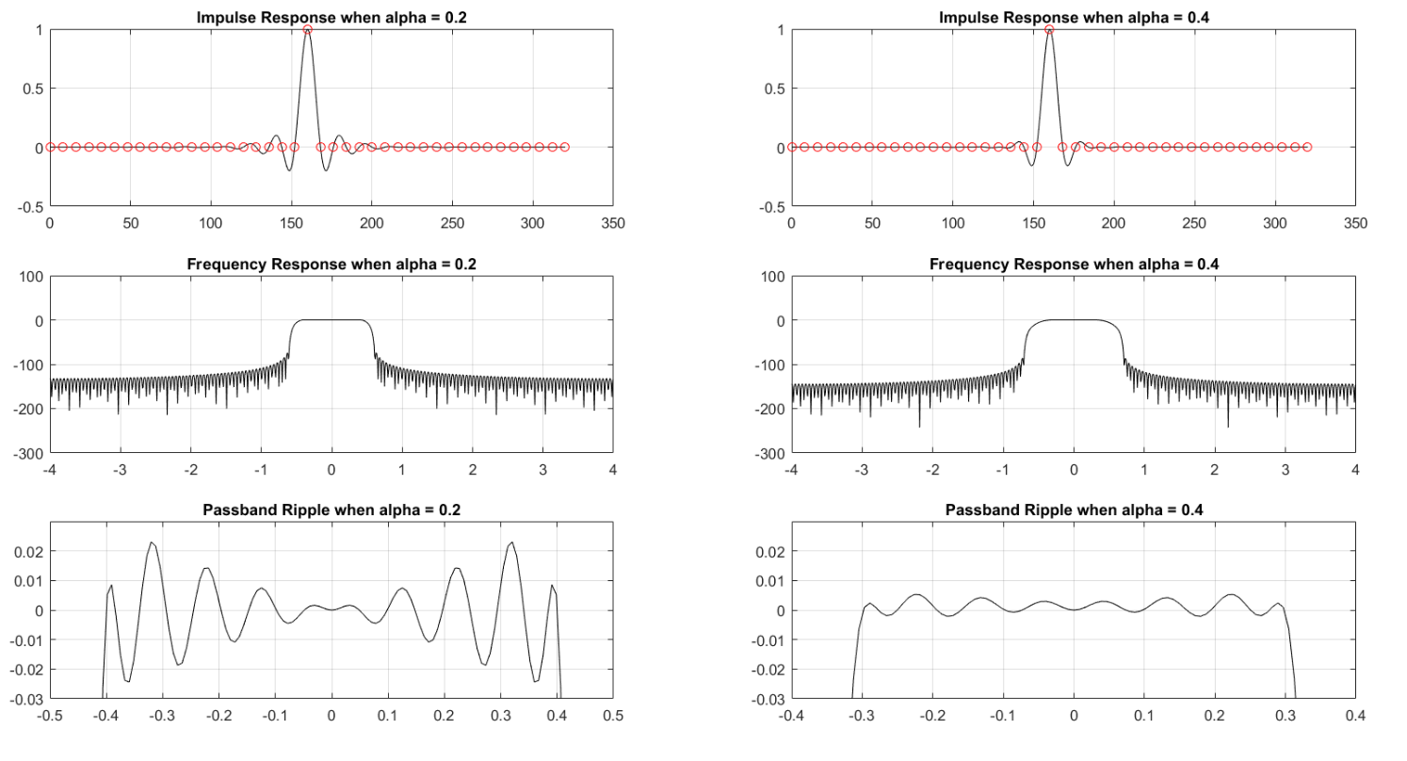Problem 2)

hm1 = h1/(h1\*h1');

y1 = conv(h1, hm1);

subplot(3, 2, 1)

plot(0:length(y1)-1,y1, 'k')

hold on

title('Impulse Response when alpha = 0.2')

plot(0:8:length(y1)-1, y1(1:8:length(y1)), 'ro')

grid on

hm2 = h2/(h2\*h2');

y2 = conv(h2, hm2);

subplot(3, 2, 2)

plot(0:length(y2)-1, y2, 'k')

hold on

title('Impulse Response when alpha = 0.4')

plot(0:8:length(y2)-1, y2(1:8:length(y2)), 'ro')

grid on

subplot(3,2,3)

plot((-0.5:1/1024:0.5-1/1024)\*8,fftshift(20\*log10(abs(fft(y1/sum(y1),1024)))),'k')

title('Frequency Response when alpha = 0.2')

grid on

subplot(3,2,4)

plot((-0.5:1/1024:0.5-1/1024)\*8,fftshift(20\*log10(abs(fft(y2/sum(y2),1024)))),'k')

title('Frequency Response when alpha = 0.4')

grid on

subplot(3,2,5)

plot((-0.5:1/1024:0.5-1/1024)\*8,fftshift(20\*log10(abs(fft(y1/sum(y1),1024)))),'k')

ylim([-0.03, 0.03])

title('Passband Ripple when alpha = 0.2')

grid on

subplot(3,2,6)

plot((-0.5:1/1024:0.5-1/1024)\*8,fftshift(20\*log10(abs(fft(y2/sum(y2),1024)))),'k')

ylim([-0.03 0.03])

title('Passband Ripple when alpha = 0.4')

grid on

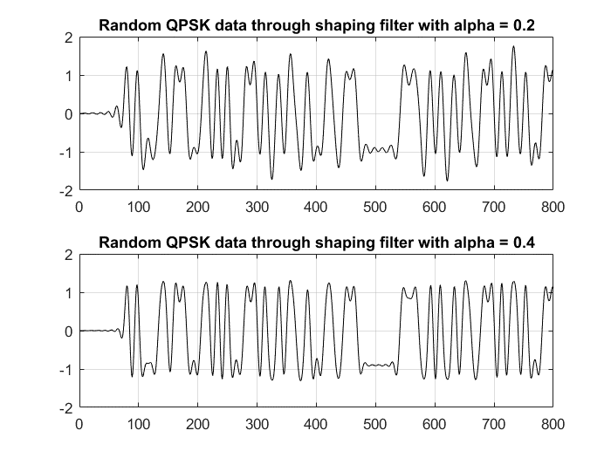 Problem 3)

N = 1000;

x0 = ((floor(2\*rand(1,N))-0.5)/0.5)+j\*((floor(2\*rand(1,N))-0.5)/0.5);

x1 = zeros(1, 8\*N);

x1(1:8:8\*N) = x0;

x1 = filter(h1,1,x1);

subplot(2,1,1)

plot(real(x1(1:800)), 'k')

grid on

title('Random QPSK data through shaping filter with alpha = 0.2')

x2 = zeros(1, 8\*N);

x2(1:8:8\*N) = x0;

x2 = filter(h2,1,x2);

subplot(2,1,2)

plot(real(x2(1:800)), 'k')

grid on

title('Random QPSK data through shaping filter with alpha = 0.4')

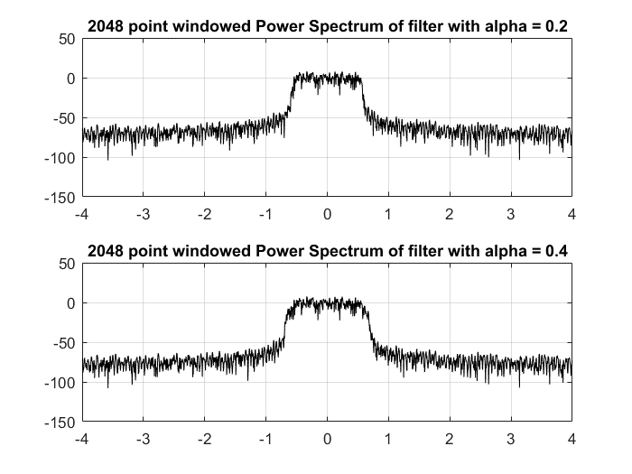Problem 4)

ww = kaiser(2048,12)';

ww = 10\*ww/sum(ww);

subplot(2,1,1)

plot((-0.5:1/2048:(0.5-1/2048))\*8, fftshift(20\*log10(abs(fft(x1(1:2048).\*ww)))),'k')

title('2048 point windowed Power Spectrum of filter with alpha = 0.2')

grid on

subplot(2,1,2)

plot((-0.5:1/2048:(0.5-1/2048))\*8, fftshift(20\*log10(abs(fft(x2(1:2048).\*ww)))),'k')

title('2048 point windowed Power Spectrum of filter with alpha = 0.4')

grid on

Problem 5)

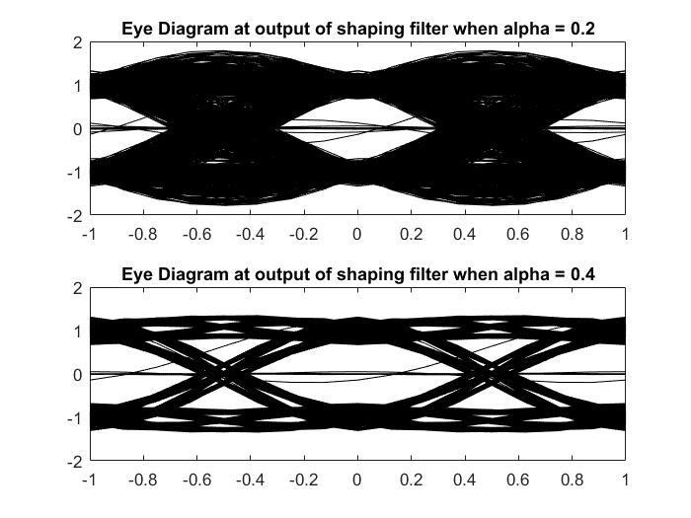

subplot(2,1,1)

plot(0,0)

hold on

for n=1:8:8\*N-16

plot(-1:1/8:1, real(x1(n:n+16)), 'k')

end

hold off

title('Eye Diagram at output of shaping filter when alpha = 0.2')

subplot(2,1,2)

plot(0,0)

hold on

for n=1:8:8\*N-16

plot(-1:1/8:1, real(x2(n:n+16)), 'k')

end

hold off

title('Eye Diagram at output of shaping filter when alpha = 0.4')

Problem 6)

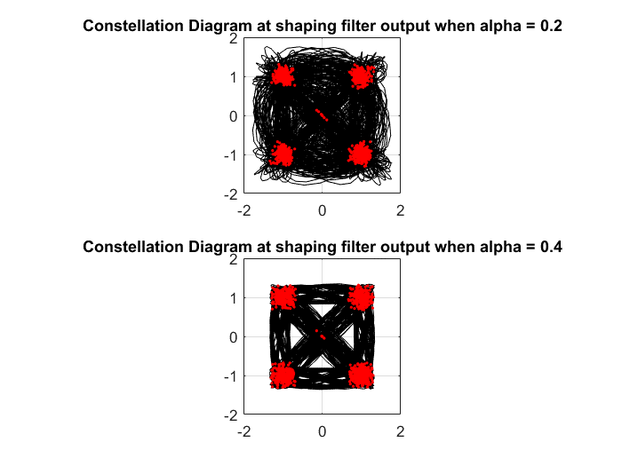

subplot(2,1,1)

plot(x1, 'k')

grid on

axis('square')

hold on

plot(x1(1:8:8\*N),'r.')

title('Constellation Diagram at shaping filter output when alpha = 0.2')

subplot(2,1,2)

plot(x2, 'k')

grid on

axis('square')

hold on

plot(x2(1:8:8\*N),'r.')

title('Constellation Diagram at shaping filter output when alpha = 0.4')

Problem 7)

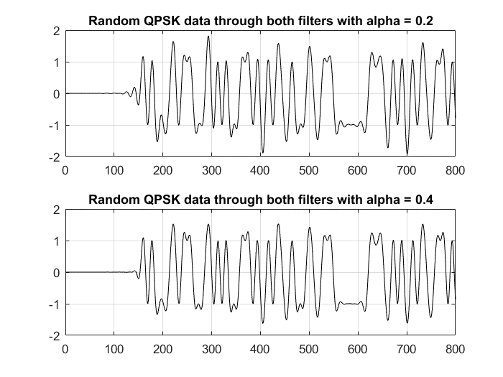

y1 = filter(hm1,1,x1);

subplot(2,1,1)

plot(real(y1(1:800)), 'k')

grid on

title('Random QPSK data through both filters with alpha = 0.2')

y2 = filter(hm2,1,x2);

subplot(2,1,2)

plot(real(y2(1:800)), 'k')

grid on

title('Random QPSK data through both filters with alpha = 0.4')

Problem 8)

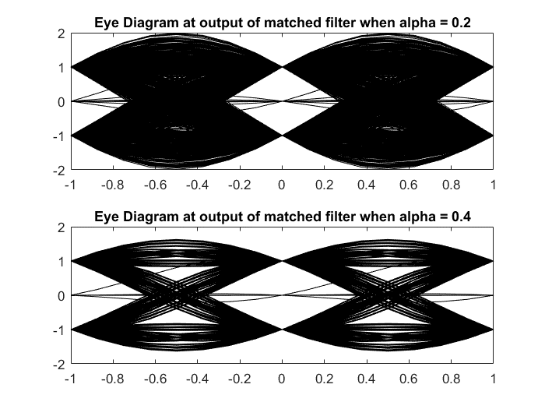

figure

subplot(2,1,1)

plot(0,0)

hold on

for n=1:8:8\*N-16

plot(-1:1/8:1, real(y1(n:n+16)), 'k')

end

hold off

title('Eye Diagram at output of matched filter when alpha = 0.2')

subplot(2,1,2)

plot(0,0)

hold on

for n=1:8:8\*N-16

plot(-1:1/8:1, real(y2(n:n+16)), 'k')

end

hold off

title('Eye Diagram at output of matched filter when alpha = 0.4')

Problem 9)

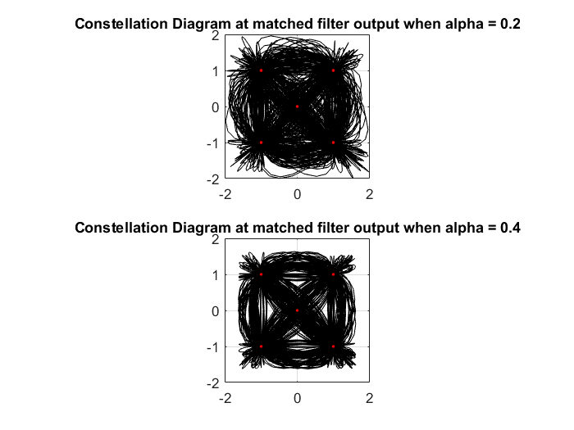

limvals =[-2 2]

subplot(2,1,1)

plot(y1, 'k')

grid on

axis('square')

hold on

plot(y1(1:8:8\*N),'r.')

title('Constellation Diagram at matched filter output when alpha = 0.2')

ylim(limvals)

xlim(limvals)

subplot(2,1,2)

plot(y2, 'k')

grid on

axis('square')

hold on

plot(y2(1:8:8\*N),'r.')

title('Constellation Diagram at matched filter output when alpha = 0.4')

ylim(limvals)

xlim(limvals)